Exercises with Functions B

When complete, save the following exercises in the folder you already created for functions -- functions_LastNameF. When finished, you can drop the folder off in the drop off.

3. Write a function def sumOfThree() to get the sum of 3 integer values. However, if any of the values is a teen -- in the range 13..19 inclusive -- then that value counts as 0, except 15 and 16 do not count as a teens. Write a separate helper def teenFix(n) that takes in an int value and returns that value fixed for the teen rule. In this way, you avoid repeating the teen code 3 times. Define the helper below and at the same indent level as the main no_teen_sum().
no_teen_sum(1, 2, 3) → 6
no_teen_sum(2, 13, 1) → 3
no_teen_sum(2, 1, 14) → 3 save as funEx3.py

4. A palindrome is a word that reads the same both forward and backwards. Examples are ‘civic’ ‘racecar’ ‘eye’ and ‘madam’. Create a function called palindrome that takes a single word as a parameter and returns True if the word is a palindrome and False otherwise.
save as funEx4.py

5. You are to write a program that calculates an employees’ weekly net income, less 21% tax and a 2% union fee, after the user has input the number of hours the employee worked and their rate of pay. Create a function called netPay(payRate,hours) which calculates the tax, union fee and net pay (the amount of pay left after deducting tax and union fees), and returns values for tax and net pay.
save as funEx5.py

6. The ascii equivalent of the decimal number 0 is 00000000, while the ascii equivalent of 255 is 11111111. To convert from decimal to ascii, first divide the decimal number by 128. If it divides once, the first ascii digit is 1. Otherwise, it is 0. Then divide the remainder by 64 to get the second digit in the ascii code. Keep dividing the remainders by half the preceding amount to get each digit in your ascii number. You need to do this division eight times (for the eight digits in your ascii byte) until you divide by 1 to get your last ascii digit.
You are to write a program that calculates the ascii numbers when given any decimal number between 0 and 255. The program is to contain a function call deciToAscii(number) that accepts the decimal argument and returns an ascii number as an eight character string. You should be able to do this in a dozen or so lines.
save as funEx6.py
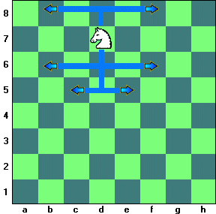
Bonus
7. Knights in chess move in an L shape. They go 2 in one direction then one space at a 90 angle, as the diagram shows. Create a function called knightMove that takes in the current location (row, col) of a knight on the chess board and returns a list of string “row, col” of all possible places the knight can move.

save as fun7.py

